 WASHINGTON HISTORICAL SOCIETY

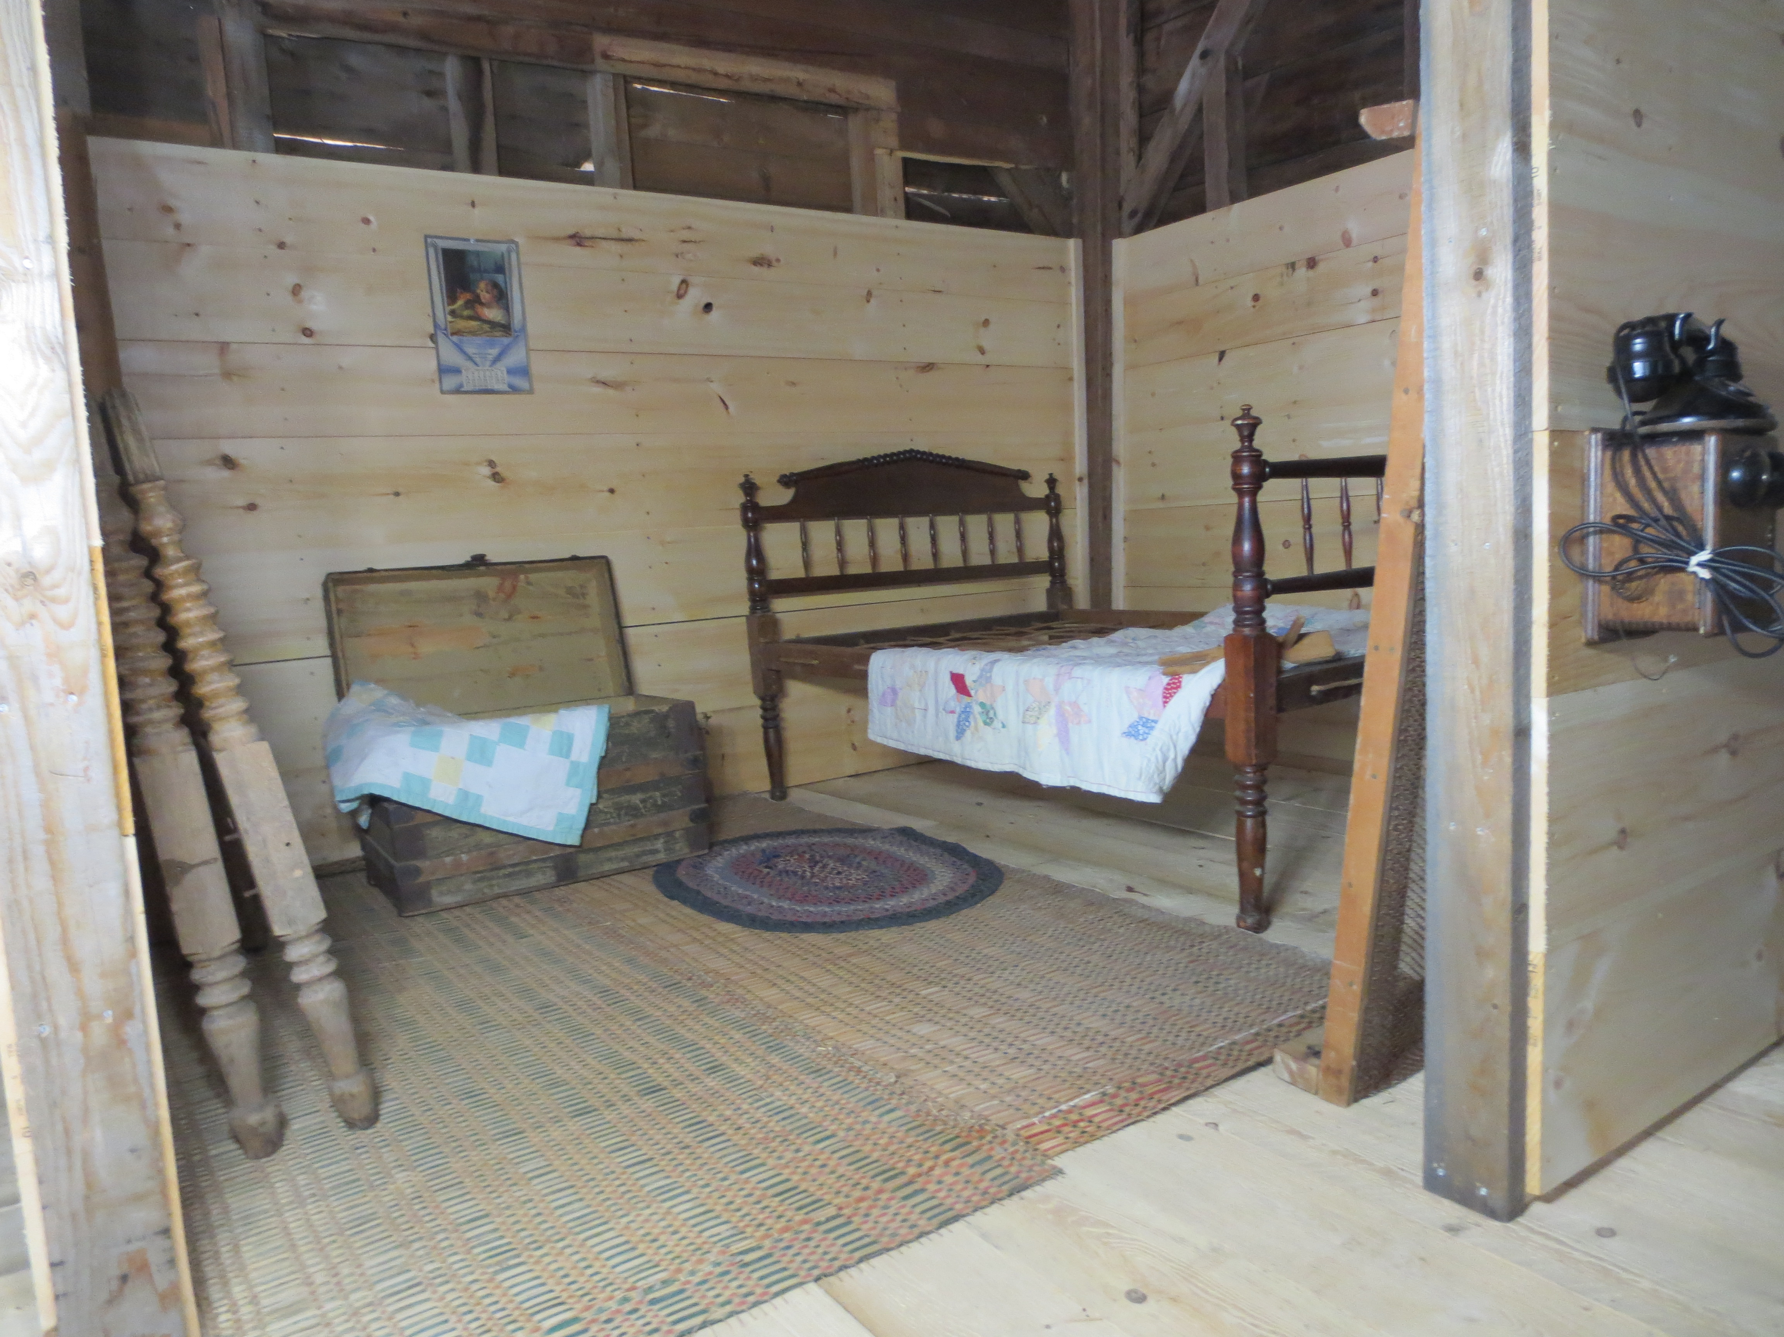

Newsletter #4 June 2017

**Students Tour WHS Museum**

Visits from 5th Grade Prescott Memorial School students to the Razorville Hall Museum and the historic Razorville neighborhood are set to be an annual event for WHS. Volunteers describe and demonstrate the various exhibits to the youngsters and explain the old-time purposes represented. The students are genuinely interested in things like a hand-crank wringer washing machine or a party line telephone from “the olden days.”

The student visits also include a tour of the Razorville section of town, just a short way from the museum. Razorville is the area around the in-tersection of Razorville Road (Route 105) and Vannah and Young’s Hill Roads. Rhoda Brann Gamage serves as guide to the former Razorville School (which is now the VFW Hall) and Razorville Chapel. The children listened attentively to stories of the early years of the school and the chapel. They were very interested and enjoyed what they learned. Rhoda was delighted to hear comments from the children that affirmed their appreciation of the visits and stories of old school days and the veterans. Many thanks to Rhoda and to Scott Whittier of the VFW for hosting the visit there.

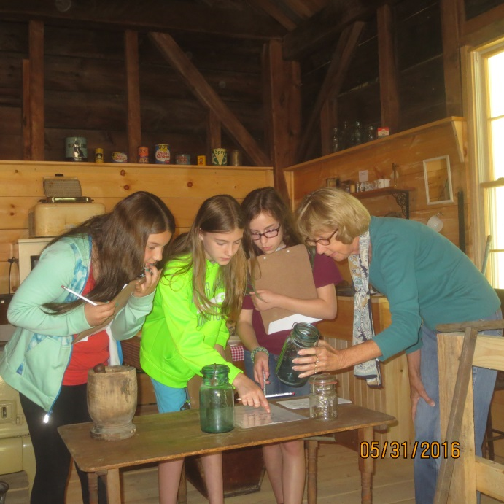

Prescott students and volunteer guide, Sandra Grinnell, look for clues to the age of these vintage

jars in the museum kitchen.

**Open Dates at Razorville Hall – Come See Us**

• Saturday**, June 10**, 10 a.m. to 2 p.m. We are hosting the Jefferson Historical Society that morning and are hoping others stop in to see our displays and new additions.

• Saturday, **July 15**, 1 – 3 p.m.

• Saturday, **August 12**, 1 – 3 p.m.

**Washington Heritage Day at Razorville Hall Saturday, September 9, 2017. 10 a.m to 3 p.m.**

• Antique appraisal with Larry Trueman for a $5 donation to the WHS. This is always an exciting and informative event. Items appraised in the past have ranged from dishes, tools, signs, guns, musical instruments, quilts & rugs, books, etc. What might you have? Here’s an opportunity to learn more about its potential value.

• Antique tractors and farm tool displays. Last year, our tractors ranged from an early 1980s pedal tractor to older John Deere and Farmall tractors, and Buckeye, a locally made tractor from the 1950s. The display should grow in number this year. Contact Don Grinnell at 845-2377 if you have something you’d like to bring for showing.

• Local fiber crafters will be there sharing their skills and projects. We plan to have spinning and carding, rug hooking, rug braiding, and weaving demonstrations going on.

• Other demonstrations such as stone cutting and blacksmithing.

• Children’s activities will include games and activities of special interest for all ages.

• annual pie contest Satisfy your sweet tooth. Bake a pie and bring it to the museum between 9 and 11 a.m. Our judges will pick a favorite and then sell slices as a fundraiser.

**• lunch barbecue at vfw hall**

**And** tour the Razorville Museum Our collection continues to grow as more local items with Washington area history are donated.

**WHS Coordinates Third Auction**

Mark you calendars now for the 3rd ANNUAL WASHINGTON COMMUNITY AUCTION on SATURDAY, JULY 29, 2017. Preview begins at 4 p.m. with silent auction items ready for bidding. The live auction starts at 6 p.m. and usually lasts about 2 hours with as many as 100 items up for bids.

The auction brings most of of our community organizations together for an enter-taining evening of sociability and money-raising to support scholarships, community projects, and each individual group’s ongoing activities. Auction items vary from gift certificates and hand made crafts to firewood or vacation opportunities and LOTS MORE! Check out this year’s auction on the Washington Community Auction’s Face-book page starting early in July.

Special thanks go to Tom Johnston, auctioneer; Phil Meunier for use of the fire station; Matt Kopishke for running the sound system, and members of the WHS for coordination and record keeping. We urge you to support this community project and get some great auction items, too!

**Town Quilt by Liz Grinnell**

During the winter we revisited the Town Quilt project. It was begun in 1979 as part of Nelson-Butterfield Day to celebrate the 200th anniversary of Washington’s settlement by those two families in 1779. The quilt was on display during that celebration and more recently was exhibited at the town office in 2011for Washington’s Bicentennial.

The creation of the town quilt was accomplished by many women in town and directed by Phoebe DeLieto of the Washington Historical Society. There are thirty-six squares depicting homes and places of local interest. Many of the squares identify who made them; others do not. Our Historical Society is trying to capture a brief biography of the person who made each square and some information about the place depicted on it. The squares for the Ladies Guild, Knox–Lincoln Women of Extension, and Mount Olivet Lodge are missing names. We also need more information about the “1875 Clark–Moore Home-stead”, the Round House by J. Bradley and “None Such Nursery School” by Murray Jamison. If you have any knowledge or memories about these squares or of anyone who worked on this quilt, please call Liz at 845-2377 or leave a note on our email washingtonhistorical@gmail.com.

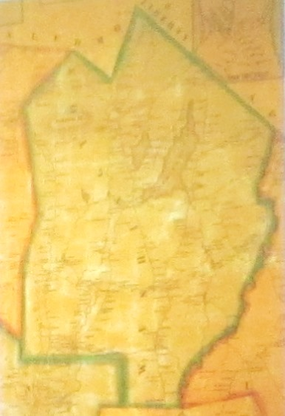

**Memorial Day Ceremony**

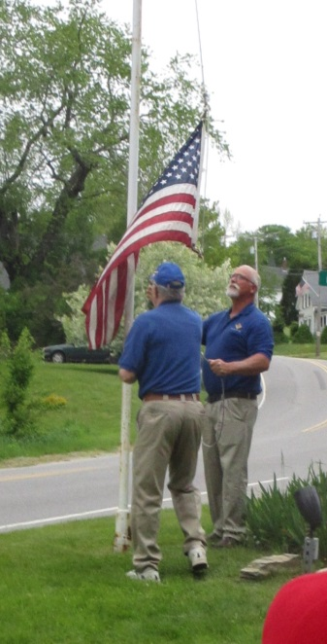Edgar Moody and Paul Barnes, of Mt. Olivet Masons, raise a new flag at the Memorial Day ob-servance. Each year, WHS with help from the Masons, Farrar-Ross VFW, and Washington Fire Dept. hold a coffee hour and memorial. The brief ceremony includes the Pledge to the Flag, the recitation of the Gettysburg Address, placement of a wreath by the VFW and music and timely messages. In recognition of the 100th anniversary of the USA entering World War I, Don Grinnell pointed out sixteen men from Washington who served during the “War to End All Wars” are named on the monument. He recognized three who lost their lives: Private Carl E. Folsom, was killed in action;

Privates Francis Cramer and Elwin Brann suc-cumbed to disease (during the influenza pandemic of 1917-18) before deploying overseas.

**~~~~~~~~~~~~~~~~~~~~~~~~~~~~~~~~~~~~~~~**

The **2018 WHS calendar** will be available for sale along with other WHS books and clothing items at Washington Heritage Day – September 9

COMING SOON . . .

**Washington 1857** **Vintage Map Reproduction**

Beautiful as decoration and

historic record

*Someplace special to meet. . .*

We welcome requests to open our facilities for exclusive visits. If you would like to create a unique occasion at the museum

for family or friends or want to peruse our archives with a personal guide, please

call Liz Grinnell at 845-2377

to schedule a visit.

The Hatch Homestead **By Norman B Casas**

In February of 1801 the General Court of Massachusetts granted Lincoln Academy a Charter and land in the mid-coast area to sell for the financing of the building of a schoolhouse. The total area granted was described as approx-imately one half of a township, which is 18 sections. A section is, for reference, a square mile.

A map that I have obtained – which was compiled in 1977 by Ed Coffin, Surveyor, from plans drawn up by several surveyors around 1815 – shows the layout of the Range A, one of the tracts offered for sale by Lincoln Academy. The Range A ran along Collamore Ridge, now called West Washington Ridge, from about present Route 17, northeast toward the northeast corner of Somerville in a long, mostly rectangular, shape. The individual lots ran across the Range, from the Ballard/Plymouth Line in the west, a distance of 340 rods, (a mile and a sixteenth), to the Range A Line in the east.

Interestingly, the Ballard/Plymouth Line which had been surveyed at an earlier date, runs along the western foot of the Ridge, and the Range A parallels it along the eastern foot close by Jackson Stream. This means that most of the lots had the full range of elevation, microclimates, and soil type that the Ridge had to offer.  The lots had varying widths, with a distance of 80 rods being common. Some lots to the northeast do not follow this pattern, and are more irregular in shape and dimension.

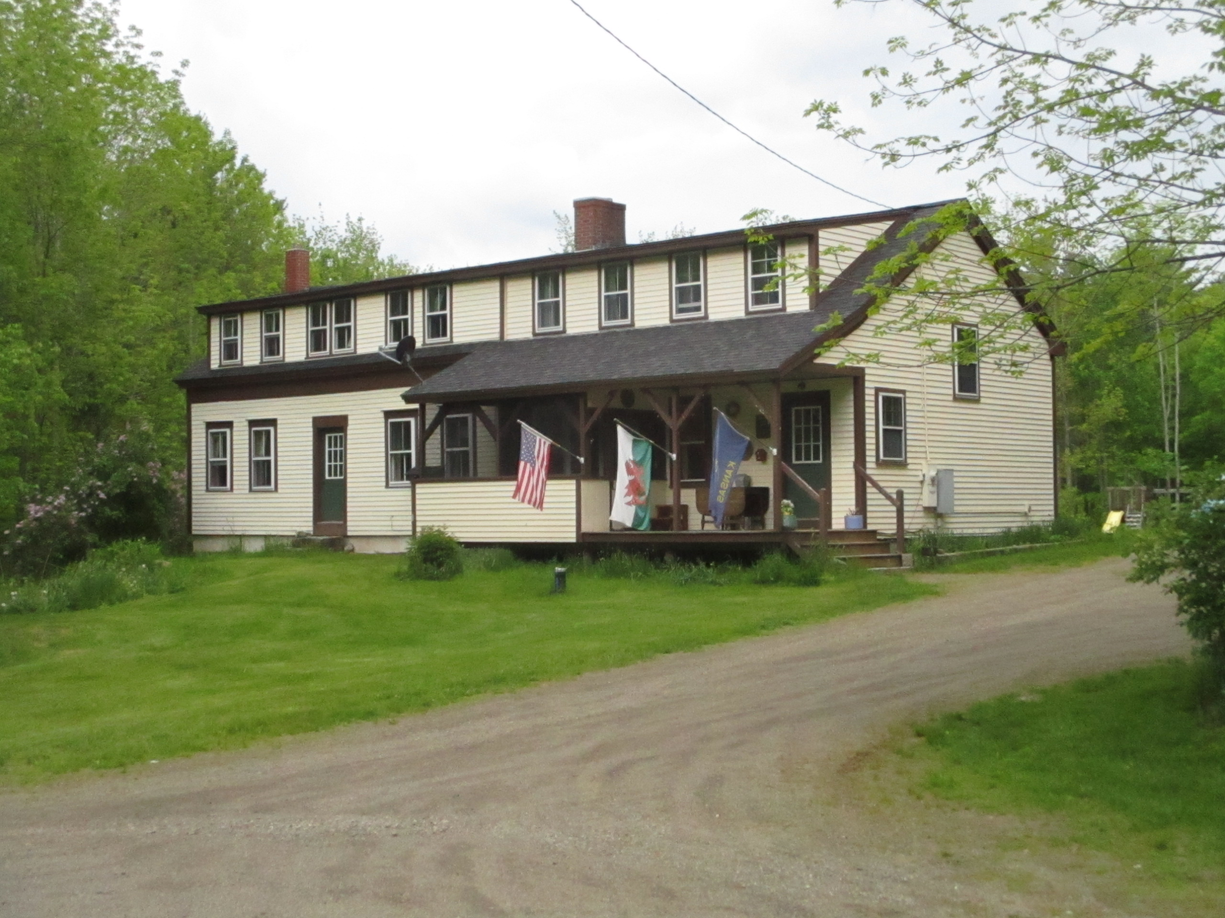

In late 1815, Major Mark Hatch was deeded a lot in the Range A about half way along the ridge. This lot is noted on a plan drawn up by Josiah Jones in 1814. The deed itself was recorded in 1819. Mark Hatch was already a settler on the Ridge as described in said deed, noted in the Hatch History Papers held by Ronnie Luce, (a descendent of Mark Hatch), and confirmed by examination of the 1810 U.S. Census. Mark, his wife Hannah, and four children under 10 years of age, were probably not living on the lot he eventually developed. The Hatch Papers claim that he had purchased two other lots before acquiring

the 1815 piece. These were apparently private sales.  The first lot’s purchase was recorded in 1806, and the second lot, adjoining the first, was purchased in 1812 . These lots are described as being “… on Collamore Ridge… near the Gore in Putnam.”  I don’t believe this Gore is the current Hibbert’s Gore located north of Washington, but it may possibly be located in the valley to the east of the Ridge, as noted on a map generated for the current Comprehensive Plan of the Town of Washington. It is not clear exactly where the first two lots were located, and further research needs to be done on this. When combined with the lot he purchased in 1815, the holdings “totaled 406 acres owned by Mark Hatch in the town of Putnam” as stated in the Hatch History Papers. The homestead and land we now own is part of the 1815 lot #37 purchase of 157 acres, and is, essentially, the portion Mark kept when he later sold, or gave, about one half of this lot to one of his sons. Mark and Hannah had 11 living children, and a number of them must have been born and raised on our property. In another newsletter, I hope to be able to expand on the Hatch Family Homestead itself, as we found it when we moved to Washington in 1971, and relate what we are finding out about the children and Mark and Hannah’s lives in the first half of the 1800’s.

The “Hatch Place” as it appears today – the home of the Norm & Libby Casas Family

**West Washington Road plotted**

At the January and February WHS meetings members began compiling a history of present-day homes and known locations of places now gone from West Washington Road (Routes 105 and 206). This is an area of town we do not have much information about and WHS wants to capture information and memories of that part of town before all is forgotten. We are still looking for more information, photos and stories. If you have something to share about West Washington please contact us. Thank you to Dean Bartlett for sharing pictures of his parent’s farm. We plan to continue documenting the buildings on other roads in town.

Oral History – Old Is New

In the early 2000s some Gibbs Library volunteers began an oral history project. Robert “Bo” Marks, Liane Chapman, and Vic Oboyski took the lead with this and taped interviews with seven now-deceased, long-time Washington residents including Clyde Sukeforth. Last fall, these long-neglected tapes surfaced and library and historical society volunteers together decided to revive the project. In February, Norman Casas, Libby Casas, Hazel Kopishke, Barbara Carney, Naomi Kirkpatrick, and Cheryl McKeary trained for taking oral histories with Oral History and Folklife Research, Inc.

Washington Historical Society

Post Office Box 333

Washington ME 04574-0333

Postal Patron

Washington Historical Society - Celebrating the Past, Embracing the Future

**Coming Events – Everyone is Welcome**

• Saturday**, June 10**, 10 a.m. to 2 p.m. We are hosting the Jefferson Historical Society that morning and inviting the public to see our displays and new additions at Razorville Hall.

• Saturday, **July 15**, Museum open 1–3 p.m.

• **Saturday, July 29, Community Auction**

• Saturday, **Aug 12**, Museum open 1–3 p.m.

**Washington Heritage Day at Razorville Hall Saturday, September 9, 2017. 10 a.m to 3 p.m.**

***Activities, Appraisals, Pie Contest, and much more throughout the day!***

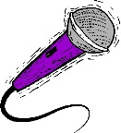

. . . more on Oral History

Maine State Library associate Adam Fisher met with some of the volunteers to explain how MSL supports oral history collection and, later, MSL transferred some of the tapes to digital format. A meeting this June will bring the project into focus and begin the scheduling for more interviews and inquiries into the best methods and equipment for our purposes. This is an on-going project and everybody who has an interest is welcome to participate. Call Hazel at 845-2760 for more information about meetings.

Non-Profit Org

U.S. Postage Paid

Washington Maine

Permit #12

**For your support and encouragement WHS sends many thanks to:**

**Our members**

**Gifters of items & memorabilia**

**Museum visitors**

**Calendar sponsors**

**Auction participants**

**Funds & goods contributors**

**Washington voters for line item in the town budget.**

**And EVERYBODY who cheers us on!**